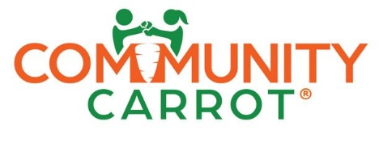
Position: Leadership Board Member, CPA/Bookkeeper
Classification | Volunteer (Pro Bono)
Position type | ☐ Full-time ☒ Part-time ☐ Temporary
Working hours | 4 hrs/month on average
Supervisory Responsibilities | This position has no supervisory responsibilities and reports to the Board Chair.

Position Summary
Community Carrot, a 501c3 nonprofit that helps break the cycle of poverty by empowering young entrepreneurs to start their own businesses, seeks a CPA or bookkeeper to help maintain the organization's Quickbooks Online accounting system. The CPA/bookkeeper is responsible for journal entries, helping to process invoices, expense reports, account reconciliations and bank deposits. The bookkeeper also keeps records of assets and liabilities and assists with preparation of financial statements and reports.

We average about a dozen transactions per month that takes about 3 hours per month. Participation at a monthly board meeting is also required. The meeting is the first Wednesday of the month, at 6pm in Seattle.

Essential functions
Essential functions of the bookkeeper include, but are not limited to, the following:

- Performing basic accounting procedures (such as accounts receivable, accounts payable, time billing, payroll, general ledger, tax payments and inventory control)
- Providing information for financial statements (such as monthly and quarterly financial reports, and monthly forecasts summarizing current and projected financial position)
- Reconciling general ledger accounts
- Filing Annual Reports (including our 990) in compliance with state and federal government
- Communicating with customers to address any past due invoices
- Providing other accounting assistance and support as requested

Competencies
- Communication proficiency, including excellent verbal and written communication skills
- Technical proficiency, including use of accounting software and web-based applications
- Excellent attention to detail
- Strong organizational skills
- Strong analytical skills
- Ability to work independently and manage multiple projects and deadlines
- Credibility and integrity, confirmed by references

Qualifications and requirements
- Associate's or more advanced degree in accounting or finance
- Two or more years of progressive bookkeeping experience
- Experience in 501(c)3 Non-Profit Accounting

Work Environment
This work will be performed at your location.
Travel requirements
No travel is expected for this position, but business needs may change this circumstance.

