M506 – Redo signage with new business name. 7/15/2026

Indoor Suite Sign:
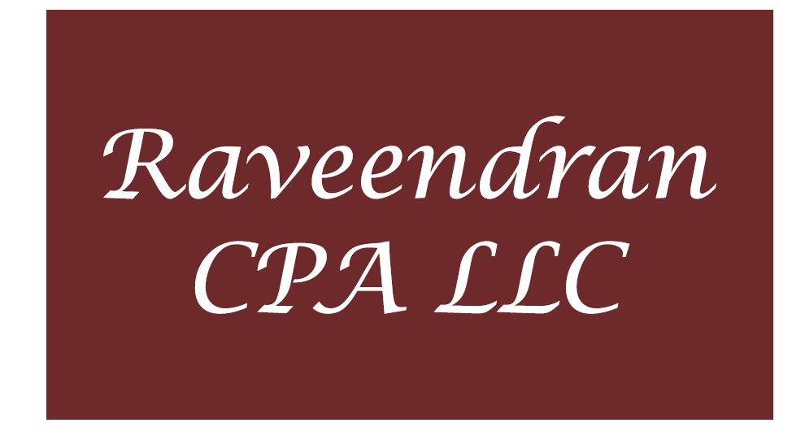

Outdoor Directory:
